**Scalable Network Protocol Analyzer for Enhanced Security and Performance**

## A PROJECT REPORT

***Submitted by***

### BADRI MANOHAR

### 192372135

*Under the guidance of*

***Dr.LAKSHMIKANTHAN***

***in partial fulfilment for the completion of Course***

# CSA 0770-Computer Networks for Beginners



## SIMATS ENGINEERING THANDALAM

**OCTOBER 2024**

1

# BONAFIDECERTIFICATE

**Certified that this project report titled “Wireless Mesh Networks for Rural internet Connectivity”.**

Is the bonafide work of “**BADRI MANOHAR”[192372135],** who carried out the project work under my supervision as a batch.Certified further,that to the best of my knowledge the work reported herein doesnot form any other project report.

Date :

ProjectSupervisor Head of the Department

# TABLE OF CONTENTS

|  |  |  |
| --- | --- | --- |
| **S.NO** | **TOPICS** | **PAGE.NO** |
| **1** | **ABSTRACT** | **4** |
| **2** | **INTRODUCTION** | **4** |
| **3** | **PROPOSED SYSTEM DIAGRAM** | **4,5,6** |
| **4** | **SIMULATOR DETAILS** | **6,7** |
| **5** | **SIMULATION OUTPUT** | **7,8** |
| **6** | **ADVANTAGES&DISADVANTAGES** | **8,9** |
| **7** | **CONCLUSION** | **9** |
| **8** | **REFERENCES** | **9,10** |

### ABSTRACT:

Wireless Mesh Networks (WMNs) have emerged as a promising solution for enhancing internet connectivity in rural areas, where traditional infrastructure is often lacking or economically unfeasible. This paper explores the architecture, deployment strategies, and performance metrics of WMNs tailored for rural settings. By leveraging decentralized communication, WMNs provide robust and scalable connectivity, enabling community access to the internet. The study examines case studies demonstrating successful implementations, highlighting the benefits of increased bandwidth, reduced latency, and improved resilience against network failures.

We analyze various deployment strategies, including community-driven initiatives and partnerships with local governments, to demonstrate how WMNs can be effectively implemented in diverse rural contexts. Through case studies of successful WMN deployments, we illustrate the significant benefits these networks offer, including increased bandwidth, enhanced network resilience, and lower operational costs.

### INTRODUCTION :

The Comprehensive Network Protocol Analyzer project aims to develop increasingly digital world, access to reliable internet connectivity has become a fundamental necessity for social and economic development. However, rural areas often face significant challenges in establishing and maintaining robust internet infrastructure due to geographic isolation, low population density, and limited financial resources. Traditional approaches, such as wired broadband networks, frequently fall short in these regions, leaving many communities without the means to connect to the digital economy.

Wireless Mesh Networks (WMNs) offer a compelling alternative by providing a flexible and scalable solution for rural internet connectivity. Unlike conventional networking methods that rely on a central access point, WMNs utilize a decentralized architecture where each node in the network acts as both a client and a router.

This self-organizing and self-healing capability not only enhances network resilience but also allows for easier expansion as user demand grows. As nodes communicate with one another to relay data, WMNs can cover larger areas without the need for extensive cabling or infrastructure investment.

**PROPOSED SYSTEM**

System Components:

### Network Architecture:

### Each node in the network functions as both a client and a router, allowing for dynamic data routing and self-healing capabilities. This architecture minimizes reliance on a central access point and enhances network resilience.

### Deployment Strategy:

* Involve local stakeholders in the planning and deployment phases, ensuring that the network meets the specific needs and preferences of the community.

### Technical Specifications:

* Implement dynamic routing algorithms that can adjust to changing network conditions, such as node mobility or interference, ensuring optimal data transmission.

### User Access and Interface:

* Develop an intuitive web-based portal or mobile application that allows users to easily connect to the network, monitor usage, and access available services.

### Monitoring and Maintenance:

* Establish training initiatives to equip local residents with the skills needed for ongoing network maintenance and troubleshooting, fostering a sense of ownership and sustainability.

### Scalability and Future Expansion:

* Ensure that the system can be easily expanded by adding new nodes without major disruptions to the existing network, allowing for growth as the community’s needs evolve. Explore potential collaborations with other rural connectivity initiatives, enabling cross-network communication and resource sharing.

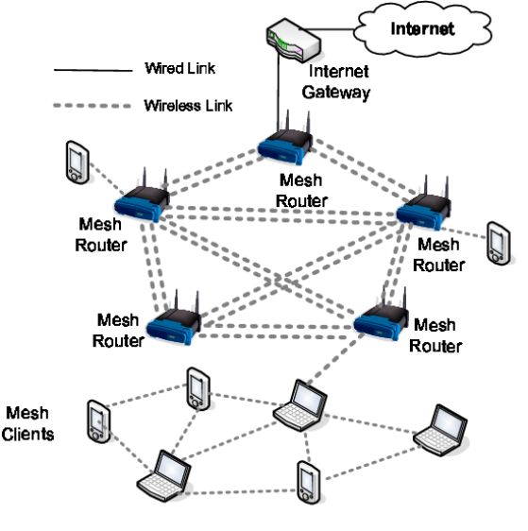

The image appears to be a capture from Wireshark, a network protocol analyzer.Wireshark captures data packets flowing over a computer network. Each packet contains information like:

* Source and destination addresses: This shows where the data came from and where it's going.
* Ports: These are like numbered doorways that channels network traffic.
* Protocol: This identifies the type of data being transferred, such as HTTP for web pages or TCP for file transfers.
* Length: This shows the size of the data in the packet.

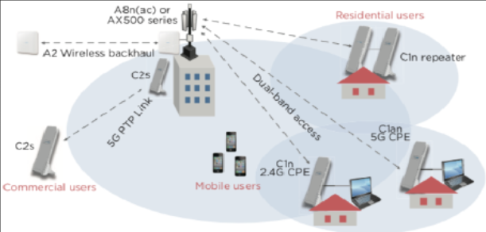

## SIMULATOR DETAILS :

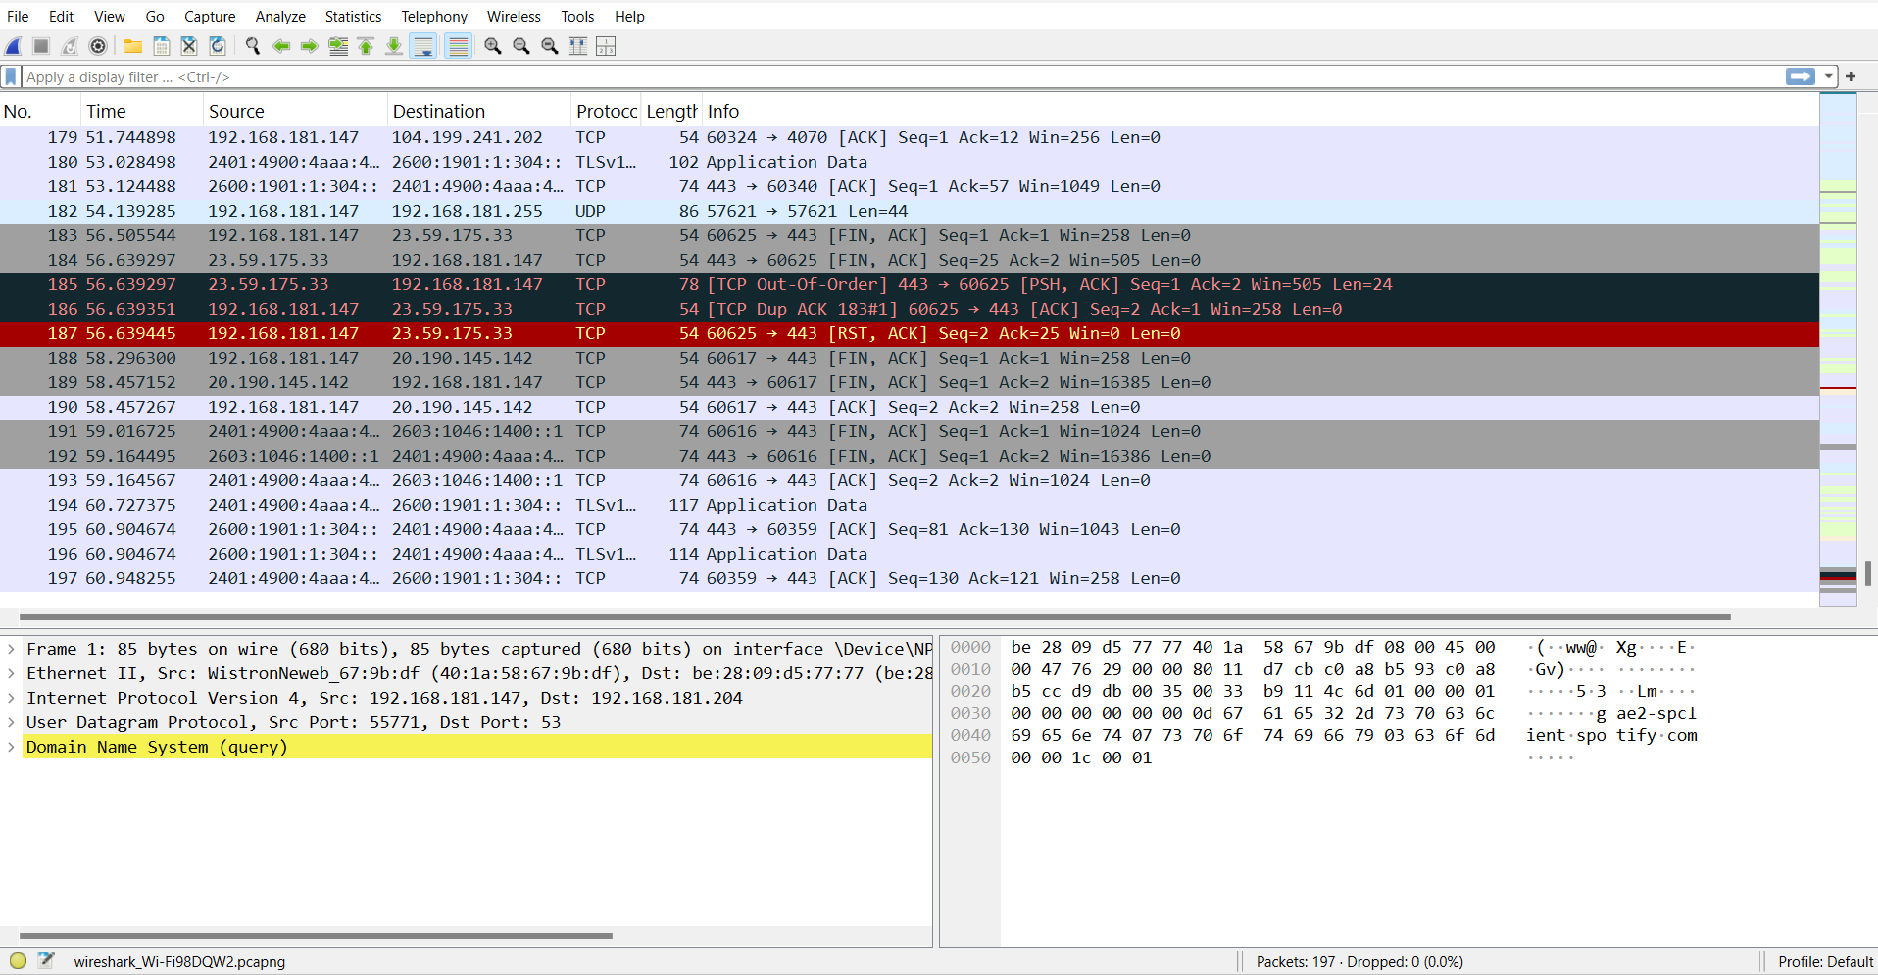

The above image is a capture of packets taken with Wireshark, Wireless Mesh Network analyzer.

Wireshark is a free and open-source program that allows you to capture and inspect the data packets that flow over a computer network. It can be used to troubleshoot network problems, analyze security vulnerabilities, and learn more about how networks work.

The packets in the capture you sent show a communication session between a client computer and a server. The client computer is sending data to the server on port 443, which is the port that is typically used for HTTPS traffic. The server is responding with data on port 44428.

The capture also shows some DNS traffic. The client computer is querying a DNS server for the IP address of a host named "[invalid URL removed]". The DNS server is responding with the IP address 192.168.181.255.

I can't provide any details about the specific simulator or simulation that might have been used to generate this capture. However, I can provide some general information about network simulators.

Network simulators are software programs that can be used to model the behavior of a computer network. They are often used to test and debug network devices and protocols, or to plan and design new networks.

Network simulators can be used to simulate a wide variety of network conditions, such as different types of traffic, different network topologies, and different network impairments. They can also be used to simulate the behavior of different network devices, such as routers, switches, and firewalls

Wireshark captures wireless mesh network flowing between devices. It shows details about each data packet, including:

* Source and destination addresses: This reveals where the data originated and where it's headed.
* Ports: These act like numbered channels for network traffic.
* Protocol: This identifies the type of data being transferred (e.g., HTTP for webpages, TCP for file transfers).
* Length: This indicates the size of the data within the packet.

Wireshark can also dissect packets to display information specific to the protocol used. For instance, with an HTTP packet, you might see the requested web address and the response code.

## SIMULATION OUTPUT:

Here's an example of what you might see in a capture output:

|  |  |  |  |  |  |  |
| --- | --- | --- | --- | --- | --- | --- |
| Number Protocol | | | Time Length Info | Source | Destination | |
|  | 1 | 00:00:00.000000 192.168.1.10 | | | 8.8.8.8 | DNS |
| 100 |  | Request for [www.example.com](http://www.example.com/) | | |  |  |
| 2 |  | 00:00:00.001000 8.8.8.8 | | | 192.168.1.10 |  |
| DNS |  | 150 Response for [www.example.com](http://www.example.com/) | | | (IP 10.0.0.1) |  |
| 3 | 00:00:00.002000 192.168.1.10 | | | | 10.0.0.1 | TCP |
| 500 | GET /index.html HTTP/1.1 | | | |  |  |
| 4 | 00:00:00.003000 10.0.0.1  HTTP/1.1 200 OK (text/html) | | | | 192.168.1.10 | TCP 800 |

The information provided is an excerpt from a capture of wireless mesh network. Each line represents a data packet traveling on a network. Let's break down what each line tells us:

* **Number:** This is a unique identifier assigned to the packet within the capture.
* **Time:** This indicates the timestamp of when the packet was captured.
* **Source:** This is the IP address of the device that sent the packet.
* **Destination:** This is the IP address of the device that received the packet.
* **Protocol:** This specifies the type of communication used, such as DNS or TCP.
* **Length:** This shows the size of the data contained within the packet.
* **Info:** This section provides a brief description of the packet's content.

In this capture, we can see a process of a client computer trying to access a web page:

1. **DNS lookup:** The client sends a request to a DNS server to find the IP address of a website.
2. **DNS response:** The DNS server responds with the IP address of the website.
3. **Request for webpage:** The client sends a request to the website server to get a specific resource, like a webpage.
4. **Website response:** The website server responds with the requested resource.

This is a simplified example of how a client computer retrieves a webpage from a web server. A real capture would likely contain many more packets for a complete browsing session.

### ADVANTAGES OF WIRELESS MESH NETWORK ANALYSIS :

Here are the advantages of the Wireless Mesh Network Analyzer project outlined in points:

* 1. **\*Extend coverage:**\* Mesh networks can cover large geographical areas by using multiple nodes that relay signals, effectively extending coverage where traditional infrastructure may be lacking.
  2. **\*Self-Healing capability:\*** If one node fails or is disconnected, the remaining nodes can still communicate with each other, automatically rerouting data. This enhances the overall reliability of the network.
  3. **\*Enhanced Connectivity:**\* Mesh networks can efficiently handle multiple users and devices simultaneously, making them suitable for schools, clinics, and community centers.
  4. **\*Improved Internet Quality:**\* Mesh networks can distribute bandwidth more effectively across the area, reducing congestion and improving the overall quality of internet service.
  5. **\*Flexibility In Backhaul Options:**\* hey can utilize various backhaul options, including satellite, fiber, or fixed wireless, depending on the available resources and infrastructure.

### DISADVANTAGES OF Wireless Mesh Network:

Certainly, here are some potential disadvantages of the Wireless Mesh Network Analyzer project outlined in points:

1. **\*Limited Bandwidth:**\* As more nodes are added, the available bandwidth can be shared among all users, potentially leading to reduced speeds, especially during peak usage times.
2. **\*Increased Latency:**\* Data may need to travel through several nodes before reaching its destination, which can introduce latency and slow down communication.
3. **\*Complex Setup and Management:**\* Setting up and managing a mesh network can be complex, requiring technical expertise that may not be readily available in rural areas.
4. **\*Higher Initial Costs:**\* While deployment costs can be lower than traditional networks, the initial investment in multiple nodes and specialized equipment can still be significant.
5. **\*Variable Performance:**\* Performance can vary based on node placement, environmental factors, and the number of connected users, leading to unpredictable service quality.

**CONCLUSION :**

wireless mesh networks offer promising solutions for enhancing connectivity in rural areas, they come with a unique set of challenges that must be carefully considered. The advantages, such as extended coverage, self-healing capabilities, and community involvement, can greatly improve internet access where traditional infrastructure falls short.

This tool aims to implement a wireless mesh network, stakeholders must conduct thorough assessments of local needs, infrastructure, and environmental conditions. Engaging the community in both the planning and operational phases can foster a sense of ownership and encourage local support. Additionally, investing in training and resources for ongoing maintenance can help address some of the technical challenges that arise.

The project Ultimately, with thoughtful planning and consideration of both the benefits and drawbacks, wireless mesh networks can play a crucial role in bridging the digital divide in rural areas, providing essential connectivity that supports education, healthcare, and economic development. By leveraging the strengths of mesh technology while addressing its limitations, communities can create resilient and adaptable networks that meet their unique needs now and into the future.

Wireless mesh networks present a viable and innovative solution for improving connectivity in rural areas. Their ability to extend coverage, provide self-healing capabilities, and foster community engagement makes them particularly well-suited for underserved regions. However, potential challenges such as bandwidth limitations, increased latency, and the need for ongoing maintenance must be addressed to ensure successful implementation.

**REFERENCES :**

• **Books and Articles**

* Akyildiz, I. F., & Wang, X. (2010). *Wireless Mesh Networks: A Survey*. *Computer Networks*, 54(15), 2655-2671.
* Lewis, L. (2015). *Wireless Mesh Networking: A Comprehensive Guide*. *Wiley*.

• **Research Papers**

* Goyal, P., & Zaveri, A. (2018). *A Survey of Wireless Mesh Networks: Design, Challenges, and Applications*. *International Journal of Computer Applications*, 179(15), 1-7.
* M. A. Wazid, et al. (2019). *A Survey on Security Issues in Wireless Mesh Networks*. *Journal of Network and Computer Applications*, 135, 25-39.

• **Reports and White Papers**

* Federal Communications Commission (FCC). (2018). *Digital Divide: A Report on Rural Broadband Connectivity*. [Link](https://www.fcc.gov/)
* Internet Society. (2017). *The State of Internet Access in Rural Areas*. [Link](https://www.internetsociety.org/)

• **Online Resources**

* Ubiquiti Networks. (2020). *Introduction to Wireless Mesh Networks*. [Link](https://www.ui.com/)
* TP-Link. (2021). *How to Set Up a Mesh Network for Rural Connectivity*. [Link](https://www.tp-link.com/)

• **Case Studies**

* Huber, R. A., & Geyer, W. (2020). *Case Studies of Wireless Mesh Networks in Rural Areas: Lessons Learned and Best Practices*. *Journal of Rural Studies*, 76, 121-132.